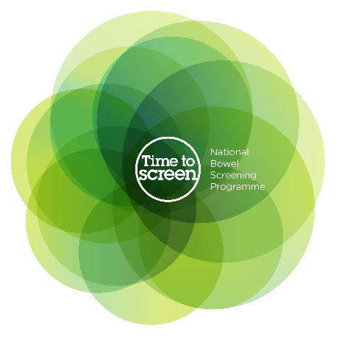
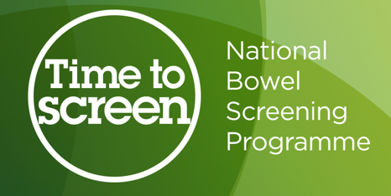

All about bowel screening

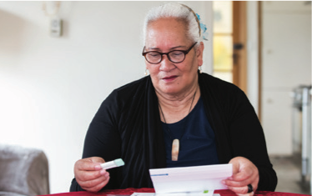


Factsheet 3 –

How to do the bowel

screening test

Before you read this document


Some of the information in this document may make people upset when they are reading it.


This information is:

- not meant to scare anyone.


If you are worried after reading this document you can talk about it with your:

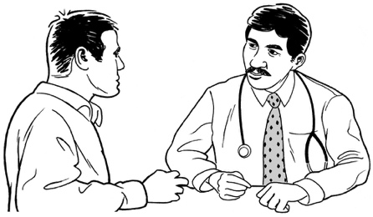
- family / friends

- doctor.

What you will find in here

Page number:

What is this document about? 5

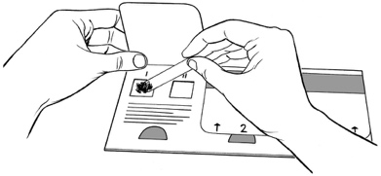
Important information about the screening test 6

How to do the bowel screening
test? 7
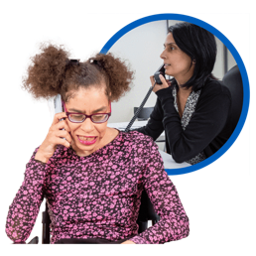

How will I get my result? 12

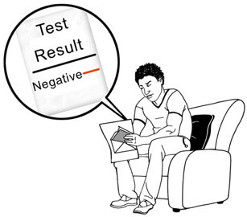
What does a negative test
result mean? 14

Page number:
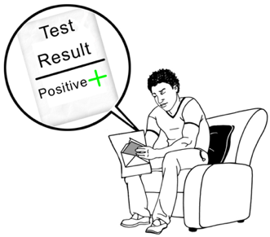

What does a positive test
result mean? 16
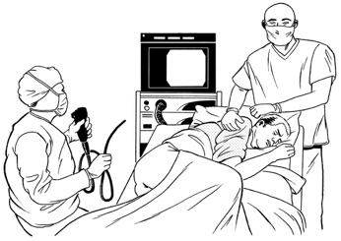

What happens if I have a colonoscopy? 20
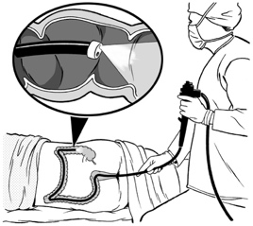

How safe is a colonoscopy? 23


Do I have to pay for any
medical costs? 24

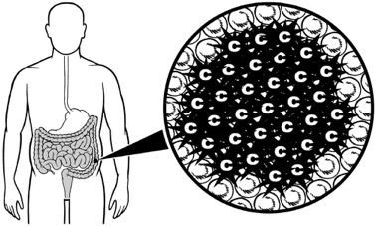
What happens if I have bowel cancer? 25
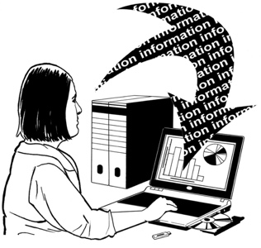

Who can see my information? 27

Page number:
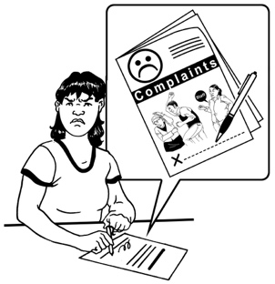

How can I make a complaint if
I need to? 29

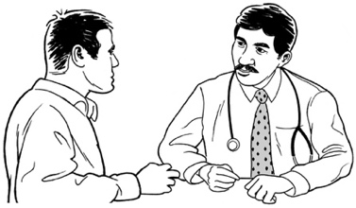
Where to find out more
Information? 31

What is this document about?

This Easy Read document tells you all about how to do the bowel screening test.

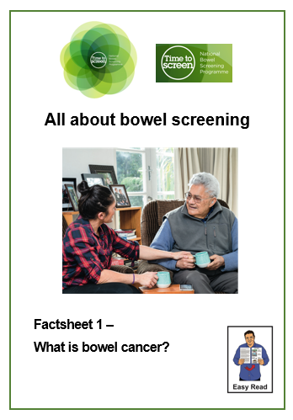
You can find more information about the bowel screening programme in 2 Easy Read documents called:

- Factsheet 1 – What is bowel cancer?

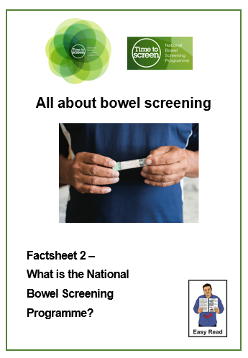
- Factsheet 2 – What is the National Bowel Screening Programme?

You can find both of these factsheets on the National Bowel Screening Programme website:

www.timetobowelscreen.nz

Important information about the

screening test


The bowel screening test is posted to your home.


The bowel screening test is easy to do in your own home.

You should do the test as soon as possible after you get it.


It is important to do the test within 6 months of getting it.

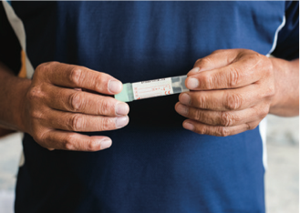

This is because we cannot get good results from old tests.

How to do the bowel screening test



You should follow all the steps carefully as you do the test.

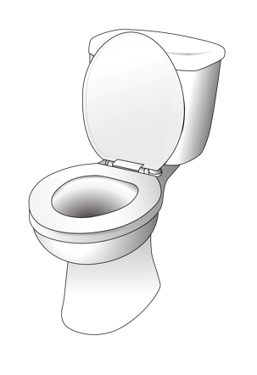
- Put the test by the toilet for when you are ready to do a poo.

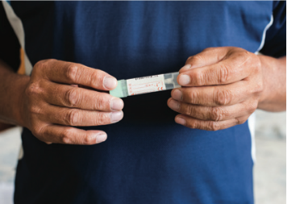
- Peel off one barcode sticker from the consent form and stick it on the flat side of the tube.
Write the date you do the test on the consent form. Check your details on the rest of the form.
- Empty your bladder by doing a wee.
- Flush the toilet.
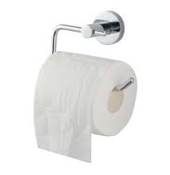

- Put some toilet paper in the toilet bowl.

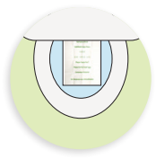
- Lay the sample sheet from the test on top of the toilet paper.

- Do a poo on the sample sheet.
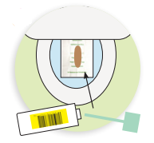

- Quickly twist the lid off the tube before the poo sinks into the bowl.

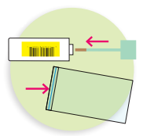
- Scrape the tip of the green test stick across the poo so the tip of the stick is well covered.

You only need a tiny sample.

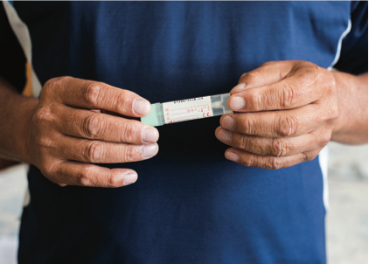
- Put the stick back into the tube.

- Push the lid on the tube down and make sure it clicks shut.
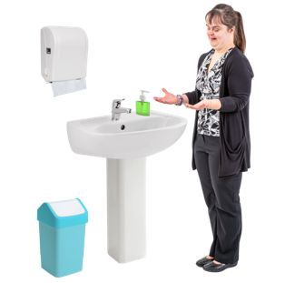
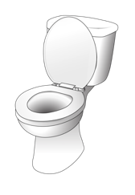
- Flush the toilet and wash your hands.

The sample paper can be flushed down the toilet.

- Put the tube into the zip-lock / plastic bag that came with the test.


- Make sure you have filled in the consent form including the date you do the test.


The consent form is the form you sign that means you say yes to doing the test.

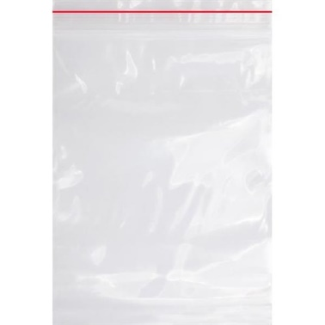
- Put the consent form into the zip-lock bag along with the tube.

- Squeeze the top of the zip-lock bag to seal it shut.
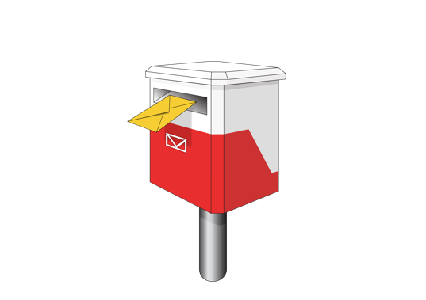
You should post your test to us as soon as you can in the envelope we have given you with the test.


You should keep in the test in a cool place out of the way of sunlight if you cannot post it straight away.

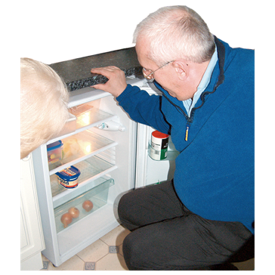
You do not need to keep the test in a fridge if you cannot post it to us straight away.

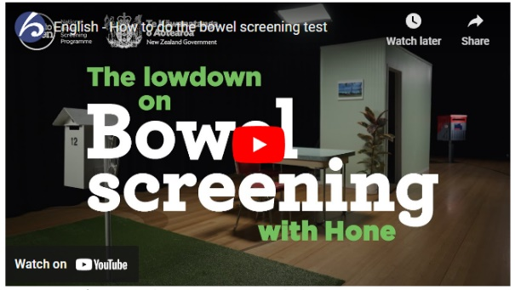
You can also watch a video that tells you how to do the test on the Time to Screen website at:

https://bit.ly/3TRutQd

How will I get my result?

Result means what the test finds.

The National Bowel Screening Programme will let you know:
- about your result

- what the result means for you.
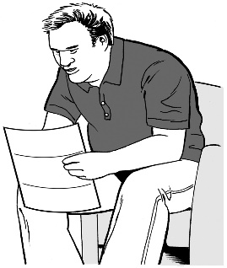

Some people may get their results by a letter only.

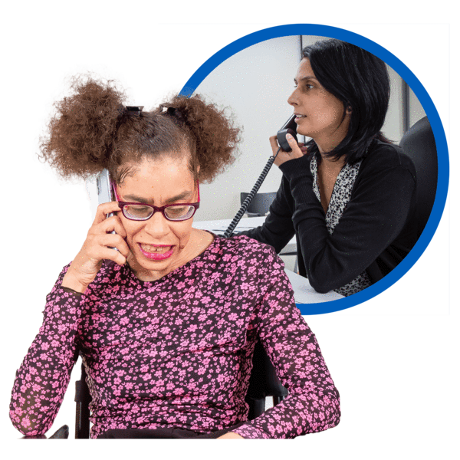
For other people it may be a phone call from:

- your doctor

- a nurse.


You will get your test result within 3 weeks of sending your bowel screening kit.

If you do not get your test result within 3 weeks you should contact the National Bowel Screening Programme by:
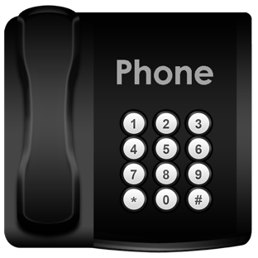
- phone on:

0800 924 432


- email at:

info@bowelscreening.health.nz

What does a negative test result mean?

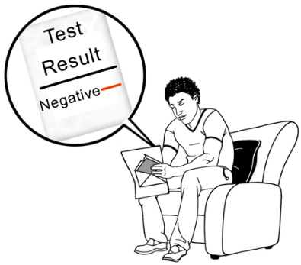
If your test result is negative this means that you do not need any more tests at this time.

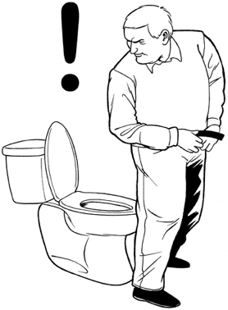
It is important to know that the screening test can find small amounts of blood in your poo.

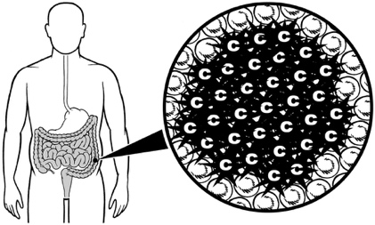
Some cancers do not bleed all the time.

This means that cancer can sometimes be missed.

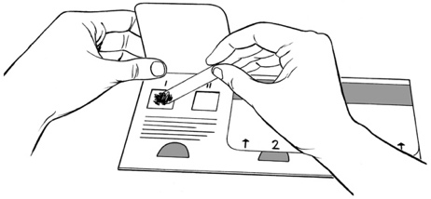
It is also important to know that bowel cancer may begin between screening tests.
This is why having bowel screening is important.




You will be asked to take a screening test again in 2 years if you are still eligible to be part of the programme.


Eligible means someone meets certain rules that means they can have / do something.

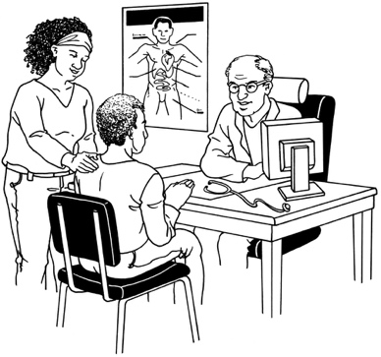
If is important to talk to your doctor straight away:

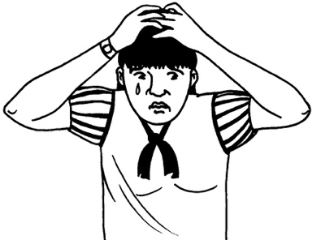
- if you have any signs / symptoms of bowel cancer like blood in your poo

- if you are worried you may have bowel cancer.

What does a positive test result mean?

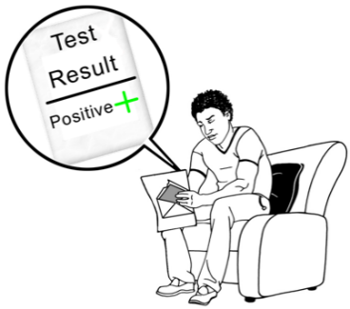
A positive screening test result does not mean you have bowel cancer.

The screening test looks for tiny amounts of blood that may be in your poo.

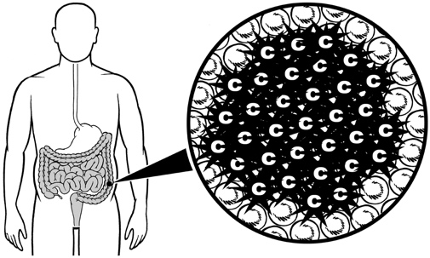
Small amounts of blood are very often caused by other conditions that are easy to treat like:


- growths of tissue also called polyps

- haemorrhoids also called piles.


It is important to know that polyps are not cancer


but

sometimes they can turn into cancer over time.

Most polyps can be easily removed if you have a colonoscopy.

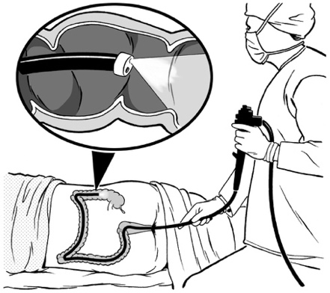
A colonoscopy is a medical test done in a hospital.

A tube with a very small camera on it is put into your bottom to check for any problems in your bowel.


You can find out more about colonoscopy on page 19 of this document.
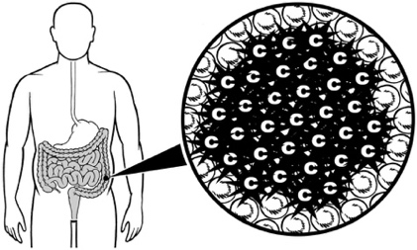
Removing the polyps makes it less likely you will get bowel cancer.
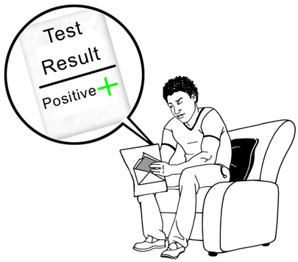

If your screening test is positive you will need to have more tests to find out what is going on.

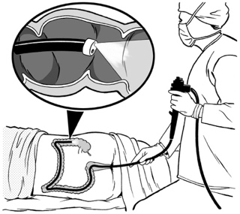
It is likely that you will need to have a colonoscopy.

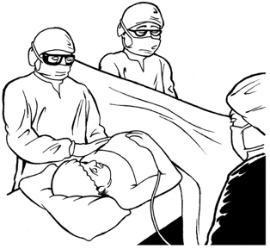
A colonoscopy can find bowel cancer at an early stage when it can often be successfully treated.
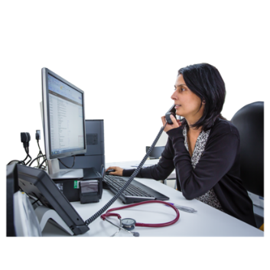

Your doctor / nurse will get in touch with you to talk about your test result.
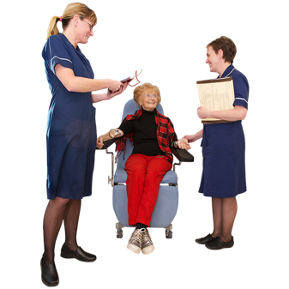

They will tell you what other tests are right for you.

If there is any history of bowel cancer in your family you may get asked to see:
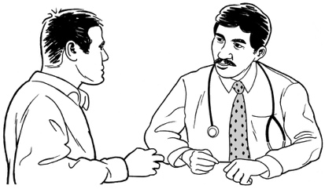
- your doctor


- the New Zealand Familial Gastrointestinal Cancer Service.

What happens if I have a colonoscopy?

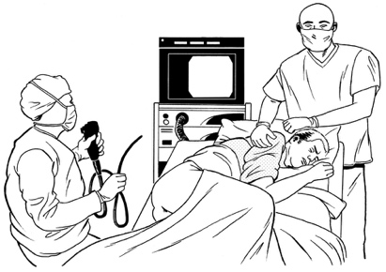
A colonoscopy is done in a hospital by a specially trained health professional.
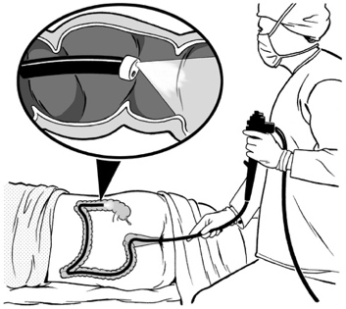

A thin tube with a very small camera on the end is put into your bottom.

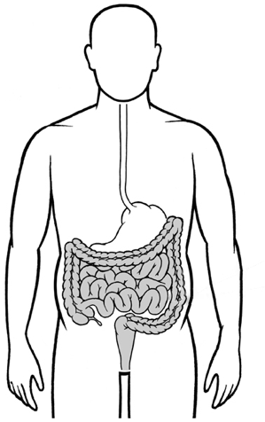
The health professional uses the camera to look at the inside of your bowel to see if there are any problems.

A colonoscopy can look for signs of:

- polyps

- cancer.

If a cancer is found a small sample called a biopsy will be taken.

If polyps are found they will usually be removed.


The biopsy / polyps are sent to a laboratory where they can be checked for cancer.

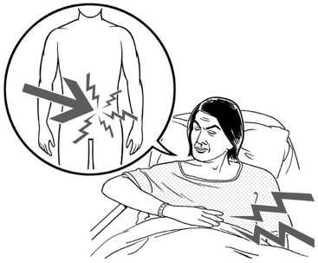
It does not usually cause any pain to:

- take a biopsy

- remove polyps.


About 7 out of 10 people who have a colonoscopy as part of the National Bowel Screening Programme will have polyps.

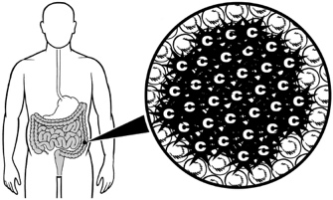
Removing any polyps may stop people from getting cancer later on.


About 7 out of 100 people who have a colonoscopy as part of the National Bowel Screening Programme will have cancer.
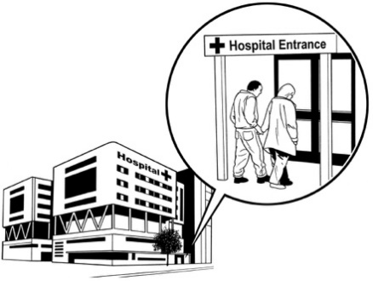

Most of those people will need medical treatment for this.

How safe is a colonoscopy?

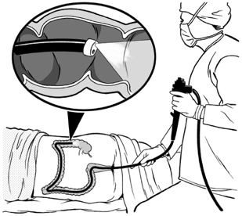
Colonoscopy is considered a safe medical procedure.


It is important to remember that all medical procedures can have some risks.

There is a small risk of serious bleeding / damage to your bowel:

- when you get the colonoscopy

- if any polyps are removed.
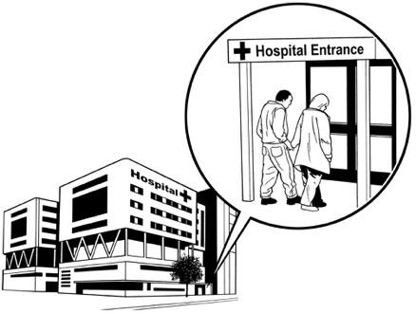

If this happens you may need further medical treatment.

Do I have to pay for any medical costs?


Medical treatment is free for everyone who takes part in the National Bowel Screening Programme.

This includes:

- having a colonoscopy

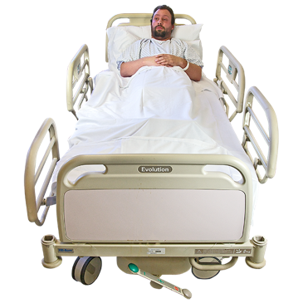
- having any follow-up tests

- any other treatment that is needed.

What happens if I have bowel cancer?

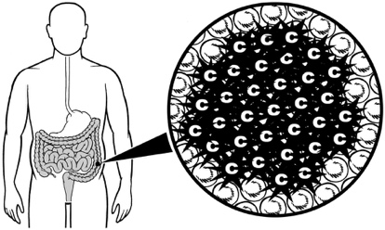
If the tests show that you have bowel cancer you will need to see a doctor who knows all about cancer called a specialist.

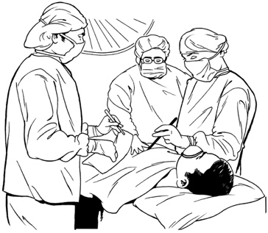
The most common treatment for bowel cancer is an operation called surgery.

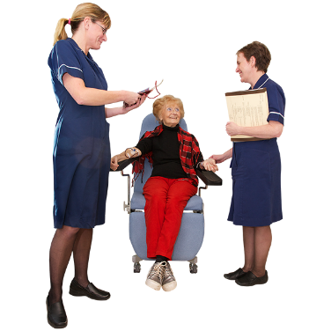
Some people may be advised to have other kinds of cancer treatment like:
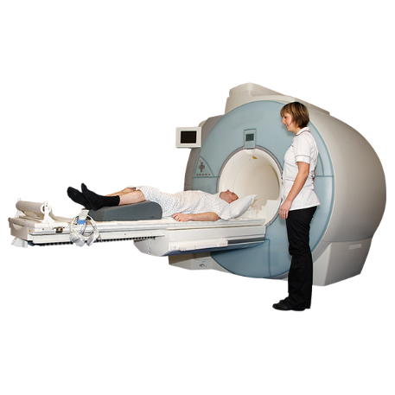
- chemotherapy

- radiotherapy.

Chemotherapy uses powerful chemicals to kill cancer cells in your body.

Radiotherapy uses high doses of energy called radiation to kill cancer cells in your body.


It is important to remember that people who find out they have bowel cancer at an early stage have a much better chance of beating it.

Cancer that is found later / when it has spread into other parts of your body is harder to treat.

Who can see my information?

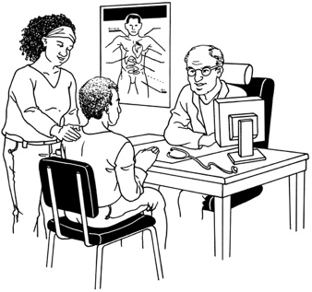
The information about any further tests / treatment you may need as part of the bowel screening programme will be collected from:
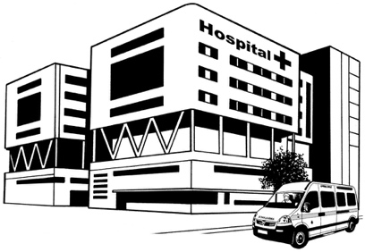
- public health services

- private health services.


This information will be used to make sure the National Bowel Screening Programme is working in the best way it can.


The National Bowel Screening Programme follows rules set out in a law called the Privacy Act 2020.

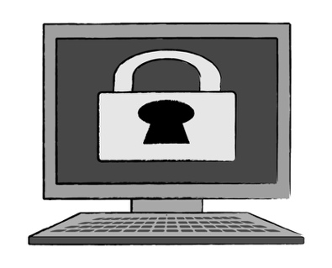
The Privacy Act means that people who work as part of the screening programme will take good care of any personal information / data they get from you.

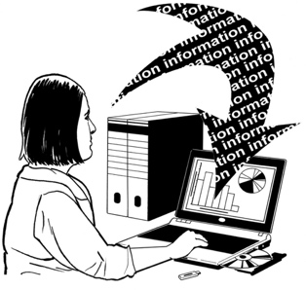
This includes:

- how they store any information

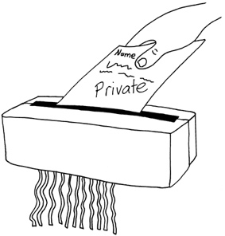
- who can see the information

- how any information is destroyed.

How can I make a complaint if I need to?

If you are not happy with the service you get from the National Bowel Screening Programme you can make a complaint.


A complaint is when you tell someone you are not happy about something.


The Code of Health and Disability Services Consumers’ Rights means you can make a complaint in a way that is right for you.


You can find out more about the Code at:
www.hdc.org.nz/your-rights/the-code-and-your-rights
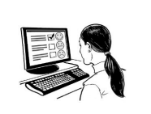
If you want to make a complaint about the screening programme / service you received you can contact the National Bowel Screening Programme:
- by phone on:

0800 924 432
- by email at:
info@bowelscreening.health.nz
You can also contact the Office of the Health and Disability Commissioner:

- by phone on:

0800 112 233

at their website at:

www.hdc.org.nz

Where to find more information

It is important that you fully understand what bowel screening is before you:

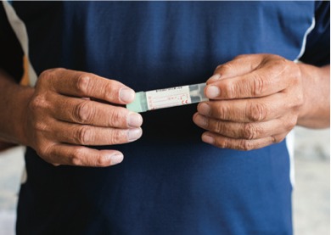
- take part in the National Bowel Screening Programme

- do the screening test.

You can find out more information about the National Bowel Screening Programme on our website at:

www.timetobowelscreen.nz

You can contact the National Bowel Screening Programme:
- by phone on:

0800 924 432
- by email at:
info@bowelscreening.health.nz

You can also talk to your doctor.

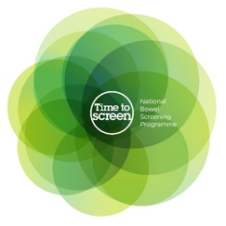
This information has been written by the National Bowel Screening Programme.


It has been translated into Easy Read by the Make it Easy Kia Māmā Mai service of People First New Zealand Ngā Tāngata Tuatahi.

The ideas in this document are not the ideas of People First New Zealand Ngā Tāngata Tuatahi.

Make it Easy uses images from:

- Changepeople.org


- Photosymbols.com


- SGC Image Works

- Huriana Kopeke-Te Aho.

Some images have been provided by National Bowel Screening Programme.

All images used in this Easy Read document are subject to copyright rules and cannot be used without permission.

